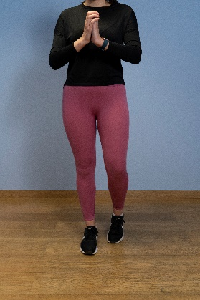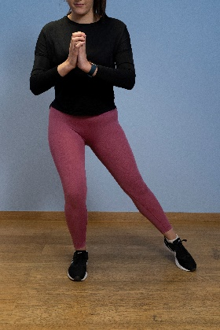

**3. Split squat**

* Place one foot forward and the other back to form a comfortable stride with the feet hip-width apart – you can gently hold on to something for balance.
* Keep the chest up and core engaged whilst simultaneously bending both knees so that the hips lower directly downwards - emphasis should be placed on pushing up through the front foot and keeping the knee in line with the hip and ankle.
* With the trailing knee just of the floor, hold this position for a count of 3 seconds before pushing down through the feet to straighten the knees and return to the starting position.
* To progress, hold a small amount of weight in the opposite hand to the leading leg and gradually increase this as strength develops.

**1. Balance and reach**

* Start by standing with all the weight on one leg.
* Rest the other foot next to the standing foot for balance.
* Now with the non-standing leg reach out sideways (hovering just above the floor) as far as possible whilst at the same time bending the standing leg.
* Then return to the start position maintaining your balance.
* Repeat in a sideways and backwards direction and continue to do this in a cycle of the three movements only touching down if you start to lose your balance.

**2. Double-leg heel raise from a step – straight legs**

* Stand at the bottom of the step facing it.
* Stand upright on the step with only the front half of each foot on the step so that the heels drop down – have a wall/stable object nearby to assist with balance.
* Push down through the front of the feet as if going up on your tip toes – the heel will begin to rise.
* Lift the heels as high as possible and then with control, slowly lower the heels all the way down over the course of a 5 second count.

15 reps / 2-3 sets / 1 minute rest

Up to 1 minute / 2-3 sets / 1 minute rest

15 reps / 2- 3 sets / 1 minute rest

Pain should not exceed 4/10 whilst completing this exercise programme.

Aim to perform this programme a minimum of once per day unless prescribed otherwise. As with any new exercise, start slowly (repetitions as able) and build up as you are able within the guidelines below.

We recommend consulting a musculoskeletal physiotherapist to ensure exercises are best suited to your recovery. If you are carrying out an exercise regime without consulting a healthcare professional, you do so at your own risk. If you have any concerns whilst completing these exercises, please contact a healthcare professional.

